Osmosis Lab

Braden Mathis
Adairsville High School
AP Biology
Mrs. Sylvester

Purpose
The purpose of this experiment is to determine how changes in solute (sucrose) concentrations affect the rate of osmosis. The secondary purpose is to use data from known concentrations of sucrose to determine the “unknown” concentration.
Hypothesis
As the concentration of sucrose inside the dialysis tubing increases, the rate of osmosis from inside of the bag to outside of the bag should also increase.
Data
Our Data
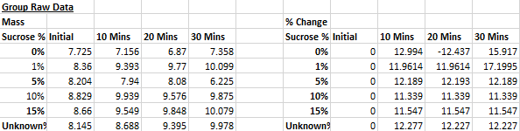
Class Data
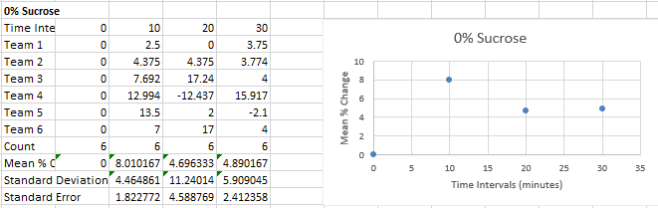
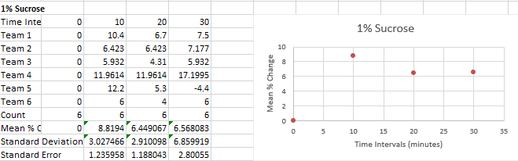
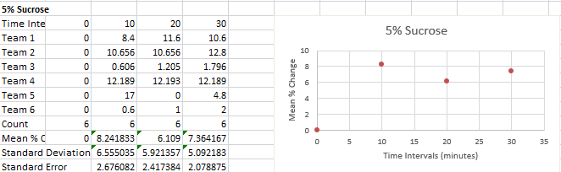
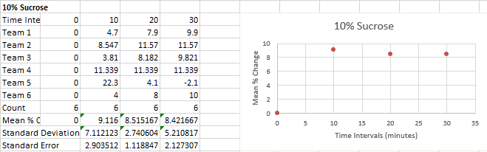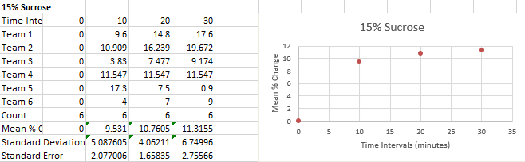
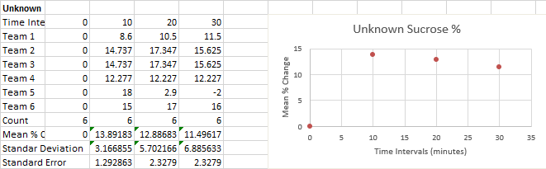
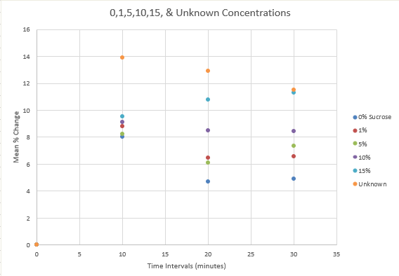
Average % Change in Mass for varying Sucrose concentrations
Observations
During this experiment one significant observation which could be made was the significant variance in data despite the same constant and manipulated variables. This later created averages significantly different from individual data due to outlier data pieces.
Data Analysis & Conclusion
Although our initial hypothesis should have been supported, in reality it was disproved. In the sample data which exemplifies how the results of this experiment should look in all varying concentrations, the rate of osmosis increases alongside time. However, in our results it can be seen that as concentrations vary so does the rate of osmosis. For example, the 0% sucrose had results which mirrored what those of varying concentrations should have looked like. On the other hand, our unknown concentration displayed a decrease in osmosis over the time intervals. All other concentrations showed no specific trend.
Errors and Inconsistencies
The high standard error of the mean is due to multiple inconsistencies and errors. These include; overall ways of running the experiment, initial masses, clip vs knot, scales, number of significant figures, and math.
Experiment Setup
During the experiment although all groups were running the same experiment they were performed in different manners. Although not proven, this could result in differing data from group to group.
Initial Masses
One continually changing aspect which should have been a constant was the initial mass of the dialysis bags. This changed in our group and others. This number should have been a constant because; all dialysis bags should have been the same length, amount of solution should have been the same, and weight of clips/string should have been the same. Because this number was the foundation for the others, since this varied, the other numbers had too as well.
Clip vs. Knot
One part of the lab was securing the contents of the dialysis tubing from leaking out rather than moving through the semipermeable cellulose membrane. This was done though both clips and string knots. These varying ways had a different mass which affected the mass and change in mass over time. There is also a possibility that these methods had varying effectiveness’s in preventing the concentrations from leaving the tubing without going through the membrane.
Scales
Different groups in this experiment used different scales with varying ranges of accuracy. This
results in varying numbers between groups which affects the accuracy of the class averages. Although the probability of this having a significant impact on the results is small it is worth mentioning as a factor possibly contributing to the high standard error of the mean.
Math
When compiling data, it was realized that different groups used differing amounts of significant figures. Some groups used two to three significant figures while others used zero. Due to the size of the numbers these variances in decimal places, this highly affects the validity of the results. Another aspect which increased the range of error was math calculations and repetitions in data. Many numbers seemed to repeat within individual group data and between groups. This can be traced back to miscalculations or other errors.
Conclusion Statement
After analyzing the data, we do not have enough evidence to support our initial hypothesis. This is because our data shows no consistent specific trends. Due to the lack of a withstanding trend in our data we can not support the hypothesis and therefore move to refute it. However, using trends of our group data rather than class we can determine the X sucrose concentration to be approximately 8%. This is because the trends of the 5% and 10% solution mimic the results of the 8%. However, the 5% has slightly lower and 10% has slightly higher trends. Through this data comparison the X sucrose % was determined.

